A Mini Project On

**JOB SEEKERS**

*Submitted by*

|  |  |
| --- | --- |
| P. SIREESHA | 16121A1291 |
| P. DHARNESH | 16121A1292 |
| S. FARHANA | 16121A1293 |
| M.H. SAI CHARAN | 16121A1294 |
| S. RAM VIKAS | 16121A1295 |
| S. ASRITHA | 16121A1296 |
| S. SURYA TEJA | 16121A1297 |
| T.MADHU PRAKASH | 16121A1298 |
| T. MAHESH BABU | 16121A1299 |
| T. KAVYA | 16121A12A0 |

Under the Supervision of

**Dr. K.K. BASEER** *M.Tech.,Ph.D.*

Associate Professor

Department of Informatoin Technology

Department of Information Technology

**SREE VIDYANIKETHAN ENGINEERING COLLEGE**

**(AUTONOMOUS)**

(Affiliated to JNTUA, Ananthapuramu, Approved by AICTE, Accredited by NBA & NAAC)

Sree Sainath Nagar, Tirupati – 517 102, A.P., INDIA

**2018 -2019**

# CONTENTS

## S.NO TITLE Page No

1. Abstract 4

2. Homepage modules 5-6

3. Private Job Modules 7

4. Government Job modules 8-9

5. Requirements 10

6 Code Concepts 11-13

7 Result 14

8 Conclusion 15

9 References 16



**ABSTRACT**

* The job search process is considered a complex and intensive procedure requiring investment in time and effort on behalf of job seekers
* This project is about the recruitment procees which is done online.
* The recruitment process here is handled by the system.this project will allow the person to apply for a job in the company for the interested vacancy which would be available at the company.

**MODULES**

* Homepage
* Private jobs
* Government jobs
* Database

**HOMEPAGE**

* It provides the latest job offers in both private and government sectors
* If you want to change the company or work for a highly reputed company you can able to fill your credentials like your designation work experience in specific field and also location you are interested to work
* Homepage is developed using php,jquery,javascript and html.



**PRIVATE JOBS**

* It provides options in which fiels you are interested to work
* Banking
* IT
* CA
* Telecom
* It is developed using php,jquery,javascript and html.



**GOVERNMENT JOBS**

* It provides options in which field you are interested to work like
* Civil Services
* Banking
* Teaching
* Railways
* Medical
* It is developed using php,jquery,javascript and html



**DATABASE**

* The entire information provided is stored in database
* Credentials provided by every user is stored in the database
* We use mysql database in order to store and retrieve the entire data

**REQUIREMENTS**

**HARDWARE REQUIREMENTS**

|  |  |
| --- | --- |
| HARDWARE | MINIMUM SYSTEM REQUIREMENTS |
| PROCESSOR | Intel® core™i3-7100U CPU@2.40GHz 2.40GHz |
| RAM | 1GB or more |
| HARD DISK | 100GB or more |
| KEYBOARD | Normal or multimedia |
| MOUSE | Compatible mouse |

**CODE CONCEPTS:**

The various concepts used in this project are

* HTML 5
* JAVA SCRIPT
* JQUERY
* PHP
* MYSQL

**HTML 5:**

HTML5 is the latest and most enhanced version of HTML. Technically, HTML is not a programming language, but rather a mark up language. HTML5 is a standard for structuring and presenting content on the World Wide Web. HTML5 introduces a number of new elements and attributes that helps in building a modern website. In this project we used 9HTML 5 pages.

**Tags used in HTML 5 pages are:**

<html> <head> <title> <body> <form> <img> <input> <a> <link> <style> <textarea> <button> <script> <div> <span> <center> <marquee>

<br> <p> <table> <thead> <tbody> <tr>

<td>

**MYSQL:**

MySQL is a database system used on the web that runs on a server side.

We use the server side to store the data, Where the list of jobs, address and contact details, location etc.,

**Methods used in MySQL files are:**

select

insert

mysqli_connect()

mysqli_query

$result->fetch_assoc

**PHP:**

PHP is

**P** a server scripting language, and a powerful tool for making dynamic and interactive Web pages. It is an embedded scripting language

In this project , We use 3 php files are used

**JAVA SCRIPT:**

JavaScript is the programming language of HTML and the Web. Which is used for validation purpose. In this project two js files are used.

1.Location.js

2.Booking.js

**Methods used in JavaScript files are:**

document.getElementById()

setAttribute()

setTimeout()

parseInt()

**RESULT**

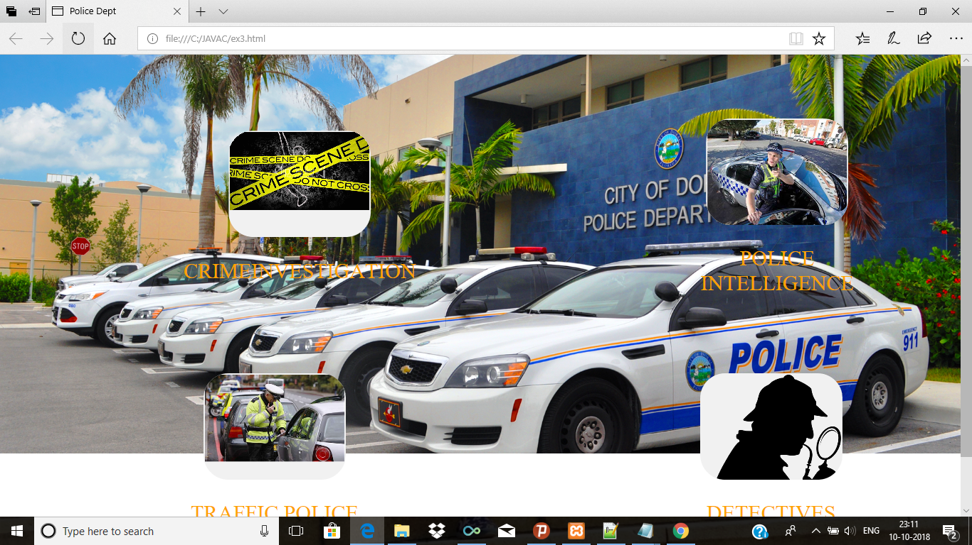









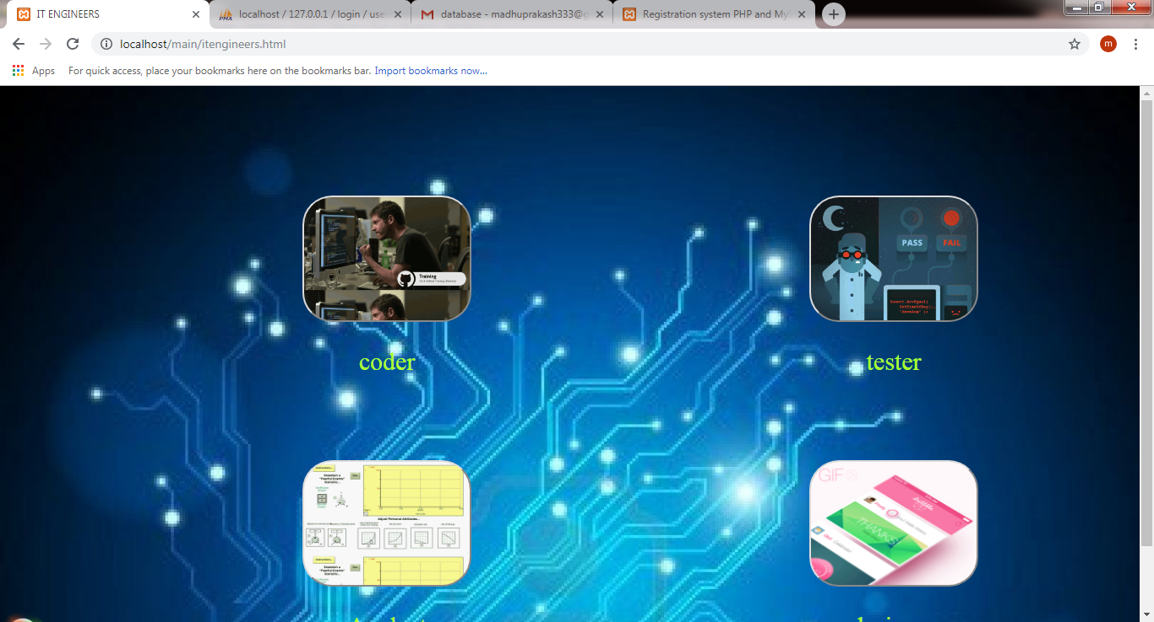

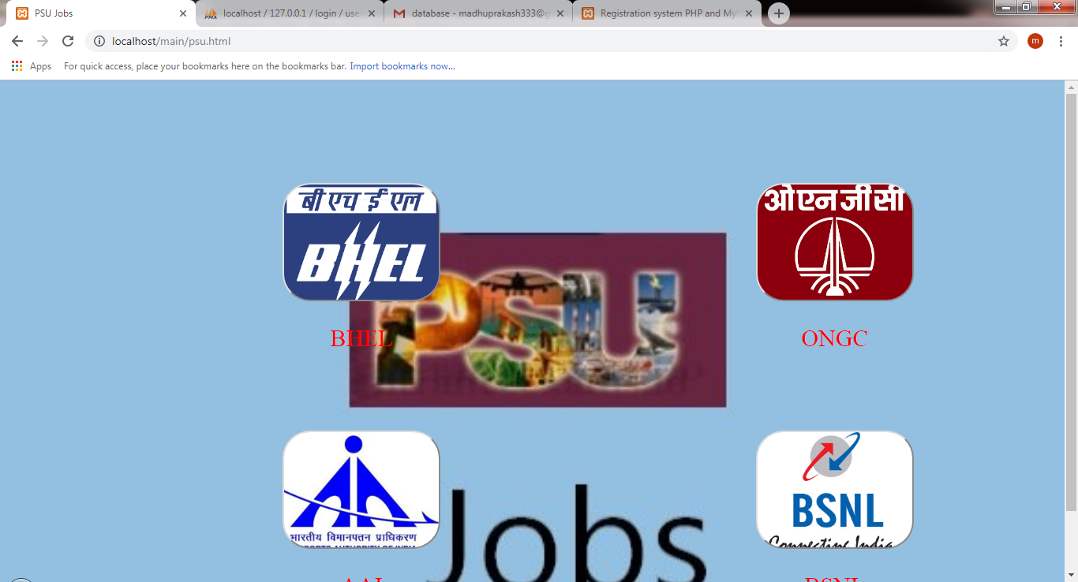

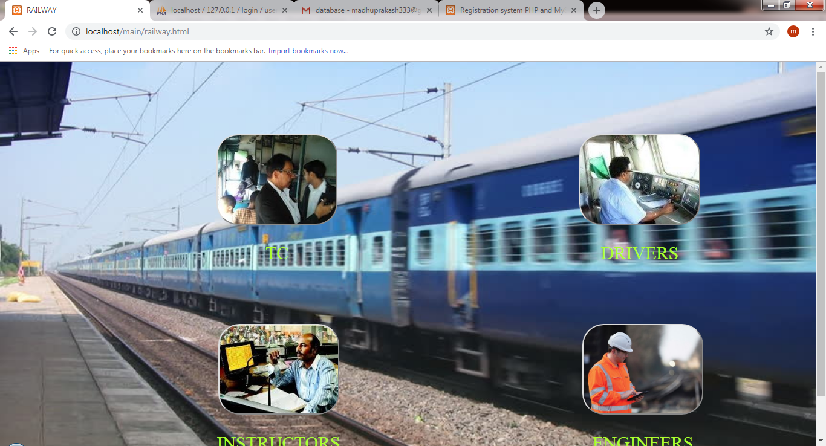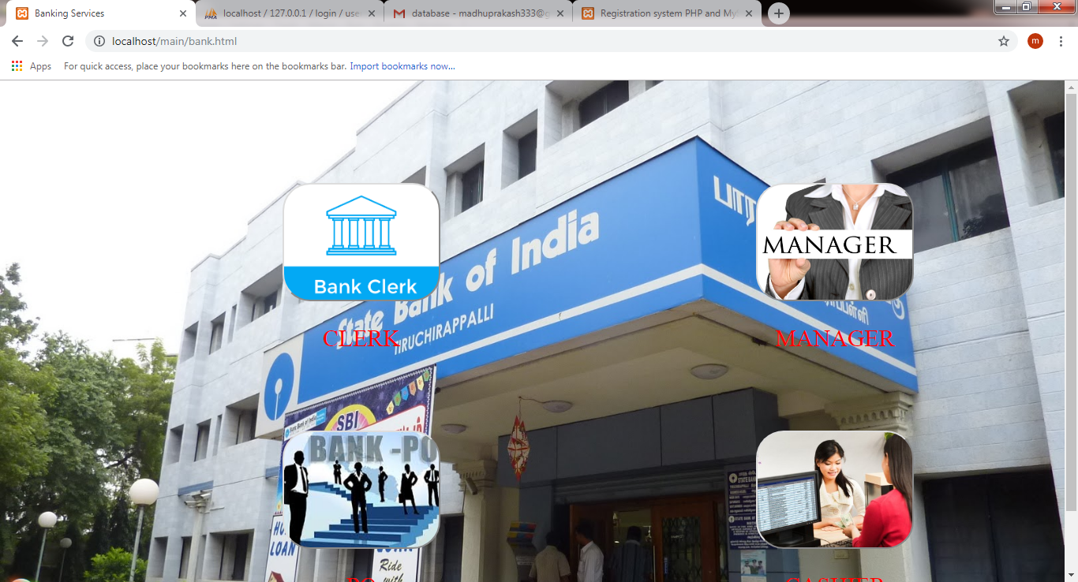

**CONCLUSION**

In this project we designed a website for finding jobs to the selected location with best companies in selected region.for developing front end we used html5.for storing the data we used mysql database which is available as a package in XAMPP SERVER .for navigating pages we used PHP.

Thus, this application helps in providing information about the jobs and for knowing the best company in selected area.

**References:**

1. Kogent Learning Solutions Inc, “HTML 5 Black Book: JavaScript,XML, XHTML, AJAX, PHP and JQuery,” Dreamtech Press, 1st edition, 2011.
2. W. Jason Gilmore, “Beginning PHP and MySQL,” APress, 4th Edition, 2011.
3. “php-concepts”, http://www.phptpoint.com
4. “basic knowledge “, www.w3schools.com